PONDICHERRY UNIVERSITY – DIRECTORATE OF DISTANCE EDUCATION MBA TWINNING PROGRAM- SPECIAL SUPPLEMENTARY ON/OFFLINE/BLENDED MODE EXAMINATION – JANUARY 2022

BACKGROUND:
In adherence to COVID 19 pandemic protocol and subsequent predicament, all administrative, academic and examination process are administered through online to ensure overall wellbeing of stakeholders. In the light of COVID 19 background, The St. Joseph’s Twinning, Bangalore center has been directed by the PUDDE to conduct supplementary examination through online/offline/blended mode from 31 January, 2022
Kindly utilize the opportunity given by the University to write your examination from your respective residence. You are requested to demonstrate professionalism and comply with the examination guidelines.
PROCESS:
All the Students enrolled for Masters in Business Administration under Twinning Model with Pondicherry University – Directorate of Distance Education through The Bangalore Jesuit Educational Society, Bangalore center are expected to strictly adhere to the following procedure.

- ELIGIBILITY TO PAY EXAMINATION FEES AND TAKE SPECIAL SUPPLEMENTARY EXMAINTION: MBA twinning program students registered with St. Josephs’ BJES center and have not completed their program/course can re-register for special supplementary examination scheduled from 31 January 2022 through online/offline/blended mode from 31 January 2022. Eligible students are requested to kindly down load and fill examination forms and take DD (Rs. 250/- Per Subject) from any Nationalized Bank in favor of finance officer, Pondicherry University payable at Pondicherry and submit your forms to MBA twinning office on or before 29 January 2022

- TIME TABLE SCHEDULE: Students are expected to go through the time table ( sent via email/ whatsapp to registered mobile number/ uploaded on the www.sjput.in)

- ANSWER BOOK COVER PAGE : Students are expected to down load the cover page of the main answer booklet from the website sent via email/ whatsapp to registered mobile number. The answer booklet coverage page should be printed and attached as first page of Answer Script after filling the relevant information (Enrolment Number, Degree/Branch, Subject Code & Title, Year/Semester, Date of Examination. All the student details have to be filled 15 minutes before the commencement of examination and attach the same after completing the examination. Answer booklet dispatched without the cover page affixed to the answer sheets will not be processed for evaluation
- Students are expected go through the time table and accordingly take-up your examination with complete preparedness and confidence
- Question papers for each exam will be sent to the student’s registered mail id between 9.45 AM to 10.00 AM.
- Any query related to your Question Paper, kindly contact institution via email id/whatsapp/call mobile number between 9.45 AM to 10.00 AM. No Phone calls or Emails will be answered after 10.15 AM strictly.
- Answers should be written on A4 white sheets/ruled sheets and must be legibly written in Ink (Blue or Black Pen). Use both side of the paper for answering questions.
- Answers should reflect the understating of the concept not verbatim copying from different sources.
- Students should check the Question paper, Subject Code/, Title of the Course etc. before answering the questions. Any deviations, kindly address/report to Chief superintendent (Dr. Kanishka)
- Each student shall send the Answer Script in individual envelopes on the same day of the examination before 2:00 PM
- It is the responsibility of student to ensure that written answer booklets are delivered by the Indian Postal Service to the Chief Superintendent (Twinning Office) during all working days. During public holidays, kindly dispatch the answer booklets through professional courier
- Down load the cover page of the answer booklet from the website and take appropriate number of photocopies ready for use
- Keep all the following examination related stationaries, technical, internet and logistics operational effective ( Cover page has prescribed by the University, A 4 White sheets, Black pen, graph sheets ( Operational paper), stapler, tag, high speed consistent network, table, chair, conducive environment with sufficient ventilation with lighting, water etc)
- late submission of answer scripts or violation of guidelines will be treated has mal practice and decision of the malpractice committee is final
- Late submission of answer scripts or any other violation of guidelines will be treated as malpractice and the decision of malpractice committee is final
- Do not appoint any representatives to engage in examination or any other academic related activities
- Do not engage or involve in multiple commitments / activities during the examination. Keep your commitment focused to ensure optimum outcome
- Students are request to take photocopy or soft backup for future reference or claim for loss paper during transit
- Ensure that all the examinations are taken-up from your respective residence or any other place which is appropriate and conducive for administrating examination effectively
- Identify the Indian postal service ( post office ) which is closest to your residence, where you can reach within 30-60 minutes from your place of writing examination
- All the students are expected to stay in Bangalore in order to access the college campus in order avail any examination related services: receiving question paper, submission of answer
- Answer Scripts will not be accepted/submitted to institution
- Each envelop should contain only one set of Answer Script.
- Answer Scripts in original are to be submitted on the same day of examinations by SPEED POST/REGISTERED POST(Only).
- While submitting Answer Script at centres, please ensure to submit in sealed envelopes.
Despatch of Answer Scripts
- The Answer Scripts should be sent in A4 size cover. The cover should contain the following information as shown below:
BY SPEED POST
ENROLLMENT NO.:
COURSE NAME :
SUBJECT NAME :
SUBJECT CODE :
DATE :
Students are expected to post your answer script in the A4 envelop addressing to
DR. KANISHKA K
Chief Superintendent
MBA Twinning Program-Pondicherry University
25, Museum Road, St. Joseph’s Evening College Campus
Bangalore, Karnataka, India
Email: csmba2021exams@gmail.com
Mobile: 8762193728 / Landline: 08022225288

From
NAME:
ADDRESS:
- The Answer Scripts should be knotted properly by using thread or staple pins. Correct procedure for attaching answer sheets is as follows:

Stapling Knotting
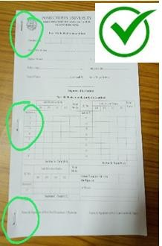
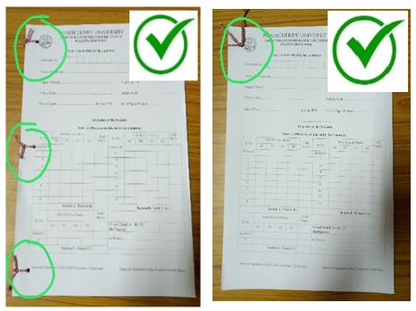

- The Answer Scripts should not be spiral bind or hard bind. These answer scripts will not be considered for valuation.
Spiral Binding Hard Binding

Note: The institution will not issue any acknowledgement for receipt of Answer Script hence students are requested to keep the Speed Post / Registered Post receipt safely for future reference.

*Kindly note: Students are expected to demonstrate professionalism during the conduct of examination process and while engaging in various examination formalities mentioned below. Minutest deviation of any nature will be considered has the breach of examination code of conduct leading to withholding of results or considering that examination null and void

